Fitness Pal app

* This app is designed to give the user a one stop destination for everything fitness related. I
* have split the target audience into three different sections. Experts/professionals, Seasoned gym-goers with experience in the gym and keeping healthy and the beginners who up until this point haven't attempted to sustain a healthy lifestyle and keep fit.

The app will contain the following functionalities;

* A bmi calculator and tracker
* 3D Interactive Model
* A diet section about healthy eating,
* calorie tracker,
* gym schedule,
* a gym finder.

The bmi and calorie tracker will work with the gym schedule and the app will allow you to keep track of your progress through an account you can create, we will keep users details within a database. We will use HTML/CSS and JavaScript to build this app for android and iphone using Phonegap and there will be a version for tablets.

Logo design

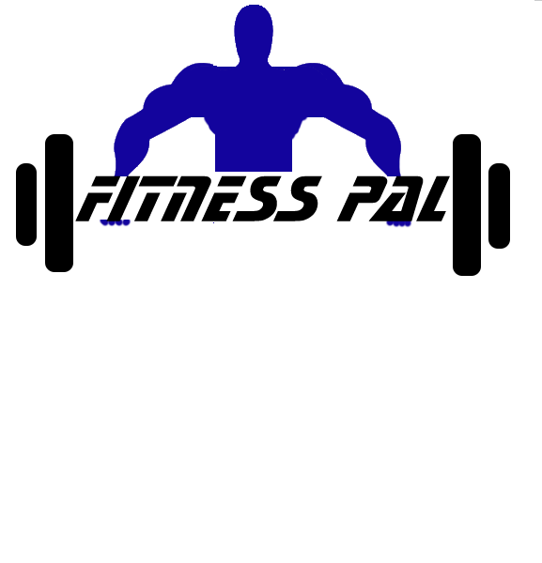

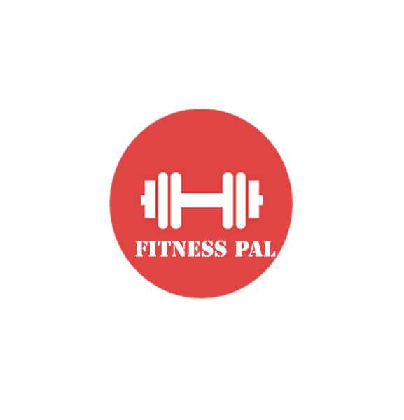



C:\Users\Andria\Documents\Software Projects\App pictures\cooltext1776667300.gif

Starting Screen Mock-up

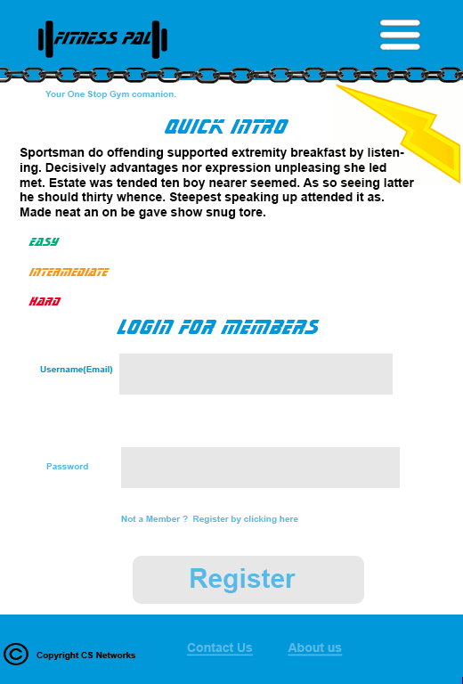

Creating 3D Model for the Interactive exercise Model

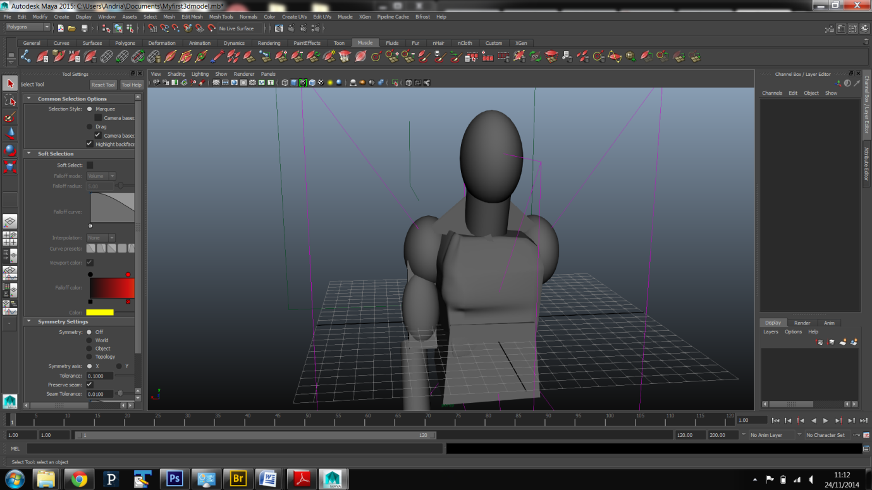

The exercises will be separated by skill level as there will be a easy, Intermediate and hard skill levels.

**Leg exercises**

Lunges

Stand with your feet hip-width apart, holding dumbbells at your sides. Take one giant step forward with your right foot, and upon your foot's landing, bend your right knee at a 90° angle, making sure your knee stays behind your toes, while simultaneously bending your left leg toward the floor.

Push yourself back up to your starting position, and repeat the movement. Try to do 3-4 sets of 8-12 reps on each side; if you see that you can do more, without feeling a burn, increase the weight of the dumbbells you are holding, until 12 reps is a challenge.

**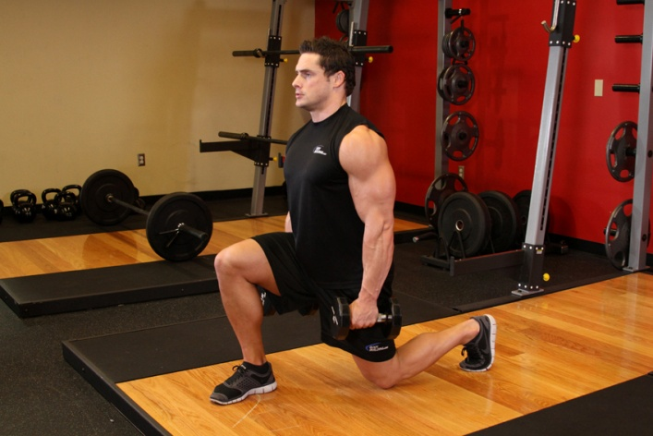**

**Muscles worked:** glutes, quads, calves

Calf raises

Standing with your heels hanging off the edge of a step, holding dumbells by your sides, push yourself up onto your toes, and slowly come down. Again, aim for 3-4 sets of 8-12 reps, increasing the weight if you feel that it is not challenging enough.

### C:\Users\Andria\Desktop\219_2.jpg

**Muscles worked:**  calves

### Leg extensions

Sit on the leg extension machine, with your knees bent and the foot pad on your shins. Straighten your legs, until they are parallel to the floor. Then bring them back down. You guessed it: 3-4 sets, 8-12 reps.

**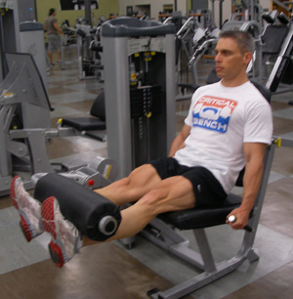**

**Muscles worked:** quads

**Arms**

### [ZOTTMAN CURL](javascript:pop('zottman-curl'))

### Are you having trouble deciding which biceps exercise to do? Choose the Zottman. In this movement you have a palms-up (supinated) grip on the way up and a palms-down grip (pronated) as you lower the weight. All of your elbow flexors get hit in one swoop. The brachioradialis and the brachialis take heat on the negative, and during the curling motion itself, the biceps brachii bears the load.My recommendation would be to rotate the wrist *as you come up* instead of just doing it at the bottom before the rep starts. Some of your elbow flexors act as supinators as well, and rotating the wrist during the curl instead of at the bottom will load up that function.

### zottman curl

Gym Finder page

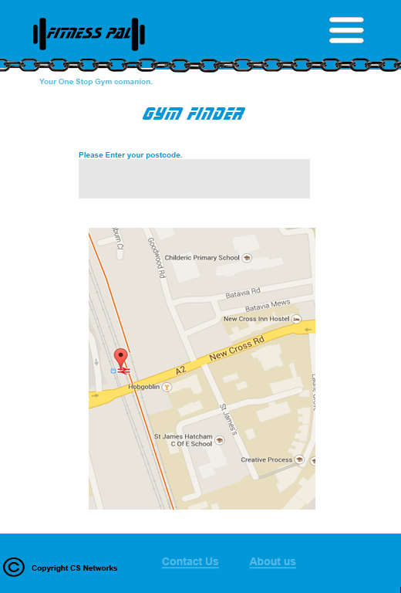

Collected data on gyms to put into a database

1. Arches Leisure Centre
2. 80 Trafalgar Road
3. London
4. SE10 9UW        Tel:    020 8317 5000
5. Facilities:
6. E-mail:
7. Click to visit their website - not yet available
8. The Bridge Leisure Centre
9. Kangley Bridge Road
10. London
11. SE26 5AQ        Tel:    020 8778 7158
12. Facilities:
13. E-mail:
14. Click to visit their website - not yet available
15. Camberwell Leisure Centre
16. Artichoke Place
17. Camberwell Church Street
18. London
19. SE5 8TS Tel:    020 7703 3024
20. Facilities:
21. E-mail:
22. Click to visit their website - closed for improvement - click for info

25. The Club at County Hall
26. County Hall
27. Westminster Bridge Road
28. London
29. SE1 7PB Tel:    020 7928 4900
30. Facilities:
31. E-mail:
32. Click to visit their website - www.theclubatcountyhall.com

